**Chapter-4 (Practice Questions Lecture-12 )**

1. Draw the logic circuit represented by each of the following expressions:
2. X= [ AB(C+D)]’
3. X = (A+B+C’DE’)’+ B’CD’
4. Draw a logic circuit for the case where the output, ENABLE, is HIGH only if the inputs, ASSERT and READY, are both LOW.
5. Draw a logic circuit for the case where the output, HOLD, is HIGH only if the input,

LOAD, is LOW and the input, READY, is HIGH.

1. Develop the truth table for each of the circuits in Figure .

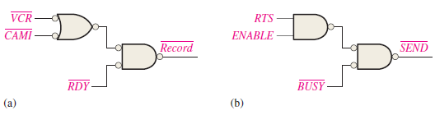

1. Construct a truth table for each of the following Boolean expressions:

**(a)** *AB* + *BC* + *CA*  **(b)** (*A* + *B*)(*B* + *C)*(*C* + *A*)

1. Using Boolean algebra, simplify the following expressions. Also draw the circuits.

(a) CE + C(E + F) + E(E + G ) (b) B CD + (B + C + D) + B C DE

(c) (C + CD)(C + CD)(C + E ) (d) AB + ABC + ABCD + ABCDE

(e) BC + (B’ + C’)D + BC

1. Determine which of the logic circuits in Figure are equivalent

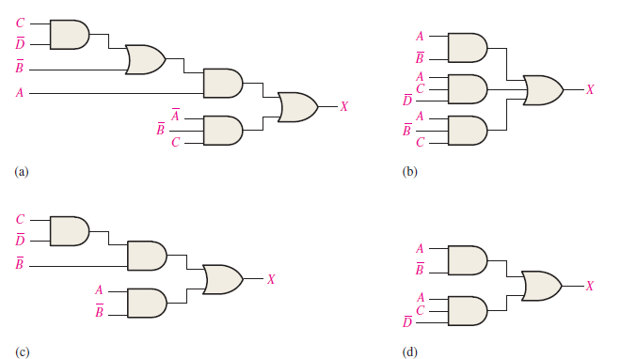

1. Convert the following expressions to sum-of-product (SOP) forms:

(a) BC + DE(BC + DE) (b) BC(C D + CE ) (c) B + C[BD + (C + D )E ]

1. Define the domain of each SOP expression in above Problem convert the expression to standard SOP form.
2. Develop a truth table for each of the following standard SOP expressions:

(a) ABC + A BC + ABC (b) X Y Z + X Y Z + X YZ + XYZ + XYZ

(c) WXYZ + WXYZ + W XYZ + W XYZ + WXY Z

(d) AB + ABC + A C + ABC

1. Develop a truth table for each of the standard POS expressions:

(a) (A + B)(A + C)(A + B + C) (b) (A + B)(A + B + C)(B + C + D)(A + B + C + D)

(c) (A + B + C + D )( A + B + C + D)(A + B + C + D )( A + B + C + D)

(d) (A + B + C )(A + B + C )(A + B + C )

1. For each truth table in Table, derive a standard SOP and a standard POS expression.

